**Program-1.1**

**Demostrating HEAD tag in html**

<html>

<head>

<title>HELLO WEBPAGE</title>

</head>

<body>

<h1>HELLO WORLD<h1>

<h2>HELLO WORLD<h2>

<h3>HELLO WORLD<h3>

<h4>HELLO WORLD<h4>

<h5>HELLO WORLD<h5>

<h6>HELLO WORLD<h6>

</body>

</html>

**Output:**

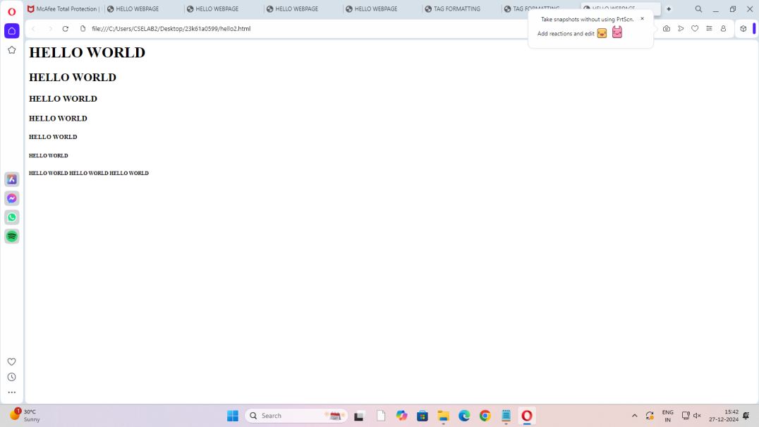

**Full Stack Development 1**

**Program-1.2**

**Demostrating HEAD tag in html**

<html>

<head>

<title>HELLO WEBPAGE</title>

</head>

<body>

<h1>HELLO WORLD<h1><hr>

<h2>HELLO WORLD<h2><hr>

<h3>HELLO WORLD<h3>

<h4>HELLO WORLD<h4>

<h5>HELLO WORLD<h5>

<h6>HELLO WORLD<h6>

</body>

</html>

**Output:**

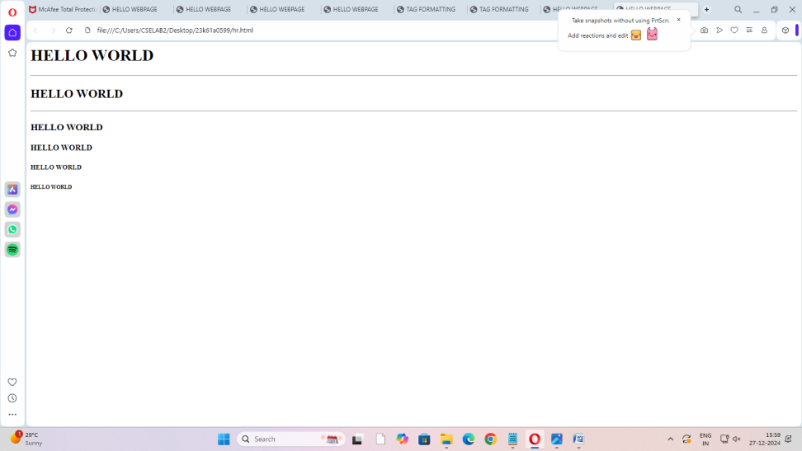

**Program-1.3**

**<html>**

**<head>**

**<title>HELLO WEBPAGE</title>**

**</head>**

**<body>**

**<h1 align="center">HELLO WORLD<h2>**

**<h2 align="right">HELLO WORLD<h2>**

**<h3 align="center">HELLO WORLD<h3>**

**<h4 align="left">HELLO WORLD<h4>**

**<h5 align="center">HELLO WORLD<h5>**

**<h6>HELLO WORLD<h6>**

**</body>**

**</html>**

**Output:**

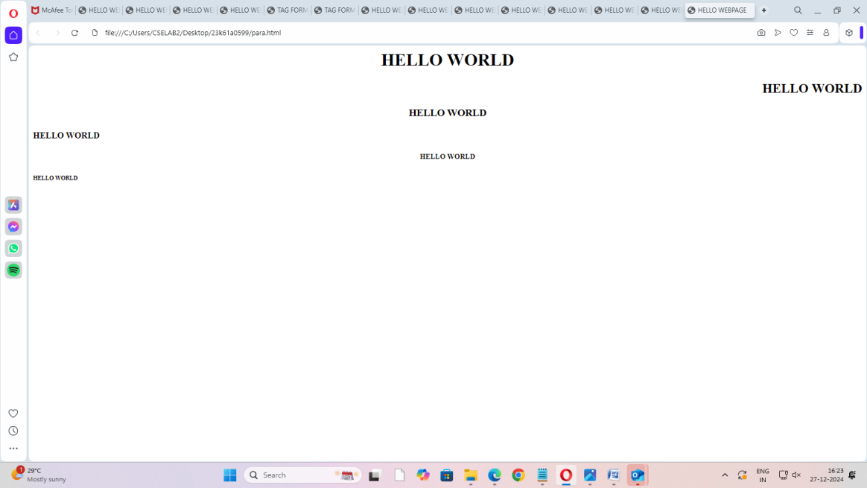

**Full Stack Development 3**